**DAILY ONLINE ACTIVITIES SUMMARY**

|  |  |  |  |  |  |  |  |  |
| --- | --- | --- | --- | --- | --- | --- | --- | --- |
| **Date:** | **01/06/202** | | | | | **Name:** | **Anjali Manohar Prabhu** | |
| **Sem & Sec** | **4th Sem Section - ‘A’** | | | | | **USN:** | **4AL18CS007** | |
| **Online Test Summary** | | | | | | | | |
| **Subject** | | **1.Complex analysis, probability and statistical method** | | | | | | |
| **Max. Marks** | | **30** | | **Score** | | | **30** | |
| **Certification Course Summary** | | | | | | | | |
| **Course** | **Introduction to Ethical hacking** | | | | | | | |
| **Certificate Provider** | | | 1. **Great Learning Academy** | | **Duration** | | | **2.5hrs** |
| **Coding Challenges** | | | | | | | | |
| **Problem Statement:** Write a Java program to calculate nPr. | | | | | | | | |
| **Status: Completed** | | | | | | | | |
| **Uploaded the report in Github** | | | | | **YES** | | | |
| **If yes Repository name** | | | | | [**https://github.com/vinisharen/lockdown-coding**](https://github.com/vinisharen/lockdown-coding) | | | |
| **Uploaded the report in slack** | | | | | **YES** | | | |

Online Test Details: MATH online test was conducted from 9:30 am to 10:10 am. The portion for the IA was MODULE 5 there were 30 questions and the time limit was 40 minutes. The questions were MCQ once. Test 1 had 10 questions and each question consisted of 1 marks each in which the total was about 10 and my score was 10/10. The TEST 2 had 10 question and each question consisted of 2 marks each in which the total was about 20 and my score was 20/20, which in total I scored 30/30

SNAPSHOT: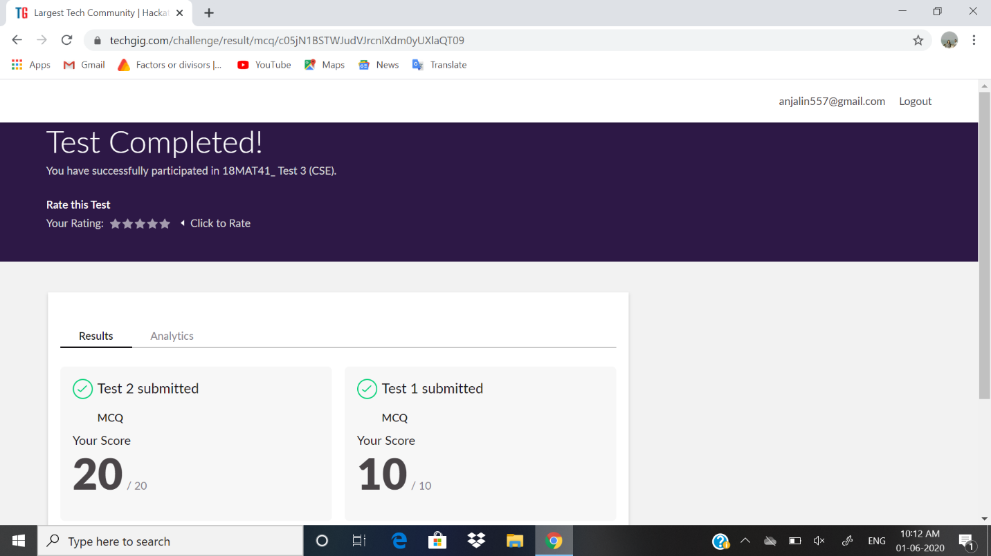

Certification Course Details:

**Ethical Hacking**, also known as *penetration testing*, *intrusion testing*, or *red teaming*, is the controversial act of locating weaknesses and vulnerabilities of computer and information systems by duplicating the intent and actions of malicious [hackers](http://en.wikipedia.org/wiki/Hacker_(computer_security)).

An **Ethical Hacker**, also known as a *whitehat hacker*, or simply a *[whitehat](http://en.wikipedia.org/wiki/Whitehat" \o "http://en.wikipedia.org/wiki/Whitehat)*, is a security professional who applies their hacking skills for defensive purposes on behalf of the owners of information systems. Nowadays, certiﬁed ethical hackers are among the most sought after information security employees in large organizations such as [Wipro](http://www.wipro.com/), [Infosys](http://www.infosys.com/), [IBM](http://www.ibm.com/ca/en/), [Airtel](http://www.airtel.in/) and [Reliance](http://www.rcom.co.in/webapp/Communications/rcom/index.jsp) among others.

**SNAPSHOT:**

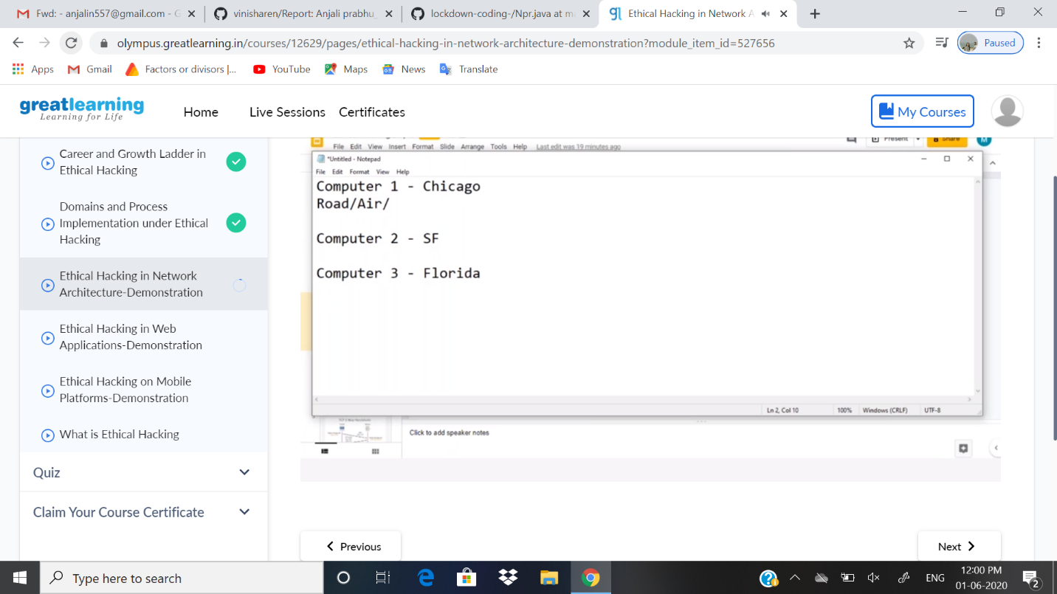

ONLINE CODING DETAILS:

PROBLEM 1: **:** Write a Java program to calculate nPr.

SNAPSHOT:

